Name:____________________________ Date:_______________________________

Do I know the properties of 3D shapes?
Cut out the boxes, and match them up on coloured paper and hand it to your teacher. Fill in the properties for each shape.

 | CONE
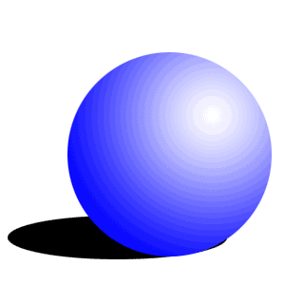 | CUBE
 | SPHERE
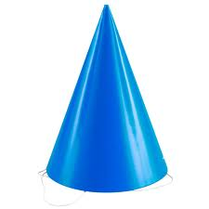 | CYLINDER

